Table of Contents

Table of Contents 1

1. Introduction 2

1.1 Purpose 2

1.2 Scope 2

➢ **Course Creation and Management** 2

➢ **User Enrollment and Access Control:** 2

➢ **E-Commerce Integration:** 2

➢ **Multi-Client Support:** 2

➢ **Reporting and Dashboards**: 2

1.3 Audience 2

➢ **Developers:** 2

➢ **Product Managers:** 2

➢ **Quality Assurance:** 3

➢ **Clients:** 3

2. Functional Requirements 3

2.1 Multi-Company Support 3

➢ **Company Profile:** 3

➢ **Course Allocation:** 3

➢ **User Management:** 3

2.2 User Restrictions 4

➢ **Role Management** 4

➢ **Access Control:** 4

➢ **Custom Permissions:** 5

2.3 E-Commerce Functionality and Payment Integration 5

➢ **Order Management:** 7

2.4 Dashboards and Reporting 7

➢ **Admin Dashboard:** 7

➢ **Learner Dashboard:** 7

3. Non-Functional Requirements 8

3.1 Performance and Scalability 8

3.2 Security 8

➢ **SSL Encryption** 9

➢ **Data Encryption:** 9

3.3 Usability and Accessibility 9

➢ **Responsive Design:** 9

➢ **Accessibility Compliance:** 10

4. Advanced Features 10

4.1 Integration with External Systems 10

➢ **API Integration:** 11

➢ **Data Synchronization:** 11

5. Conclusion 11

1. Introduction

1.1 Purpose

This document outlines the detailed specifications for the design, functionality, security, and advanced features of the software platform. The platform is designed to support multiple organizations (clients), where one company can create courses, and other companies can purchase and view these courses. Each organization has its own private area for managing users, viewing purchased courses, and accessing specific content. The system includes robust payment processing, user role restrictions, dashboards for reporting, and a flexible course management system.

1.2 Scope

This platform is built to facilitate:

* **Course Creation and Management:** Companies can create and manage courses, which are available for purchase by other companies.
* **User Enrollment and Access Control:** Different roles (Admin, Learner, Instructor) will have varying levels of access, ensuring only authorized users can perform specific actions.
* **E-Commerce Integration:** Companies can list their courses, and other companies can purchase them through secure payment gateways.
* **Multi-Client Support:** Each client (company) has its own distinct space for managing its users, courses, and financial data.
* **Reporting and Dashboards**: Admins and clients will have customized dashboards for managing courses and tracking performance.

1.3 Audience

This document is intended for:

* **Developers:** For implementation of the functional and technical aspects.
* **Product Managers:** To ensure alignment with business goals.
* **Quality Assurance:** To test and validate all functionalities against requirements.
* **Clients:** To understand the capabilities and limitations of the system.

2. Functional Requirements

2.1 Multi-Company Support

**Description**

The platform will allow multiple organizations to register, create, manage, and sell courses. Each company will have its own isolated environment, providing a separate workspace for their course listings, user management, and financial transactions. When one company creates a course, other companies (clients) can purchase and access those courses through a dedicated client area.

**Example**

Organization A creates a set of advanced marketing courses, and Organization B (a client) purchases these courses. After purchasing, the courses will be displayed in Organization B’s client area for their users to access.

**Feature Breakdown**

* **Company Profile:** Each company will have a profile with customizable settings (branding, course offerings, access control).
* **Course Allocation:** Each company can create, manage, and allocate courses to their own catalog. Other companies can browse and purchase these courses.
* **User Management:** Admins from each company can manage their users (adding, removing, assigning roles such as learner, instructor, or admin).

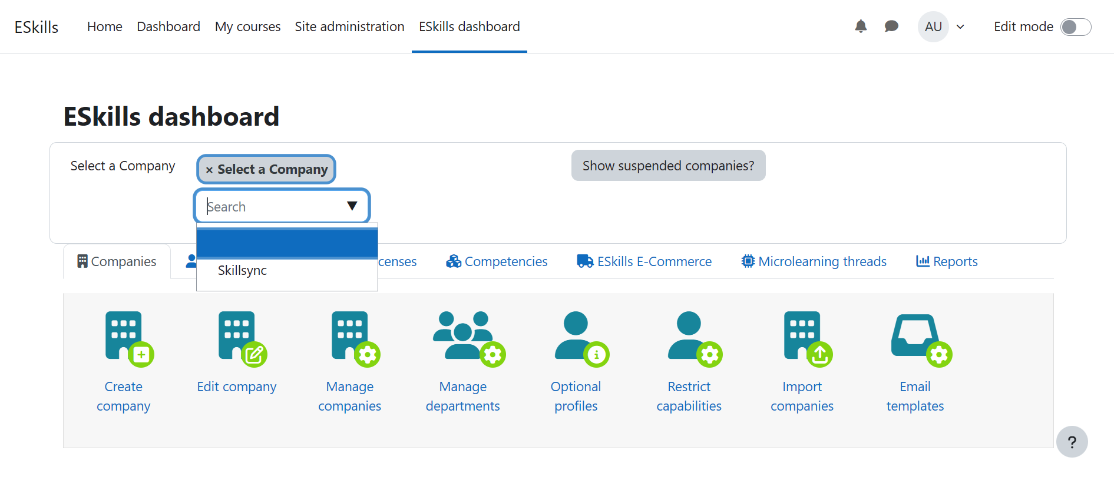2.2 User Restrictions

**Description**

The platform will allow companies to set restrictions based on user roles (Admin, Learner, Instructor). Admins will have full access to all functions, while learners will have limited access to courses and their personal progress. Instructors will be able to create and manage courses for their respective company.

**Example**

A company admin can add learners to courses, but learners can only view and participate in the courses they are enrolled in. An instructor can create and edit courses but will not be able to manage user roles or make financial changes.

**Feature Breakdown**

* **Role Management:** Define and manage roles with specific permissions (Admin, Instructor, Learner). 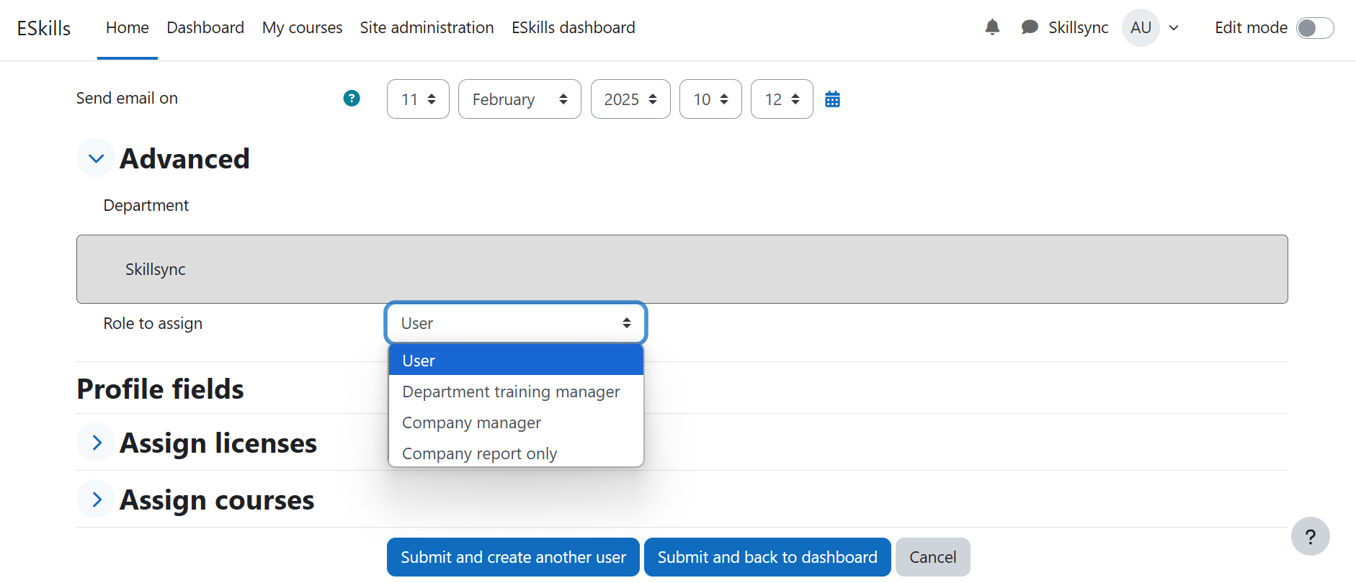
* **Access Control:** Limit access to certain areas of the platform (e.g., learners can only access their enrolled courses, while instructors can manage content).
  + 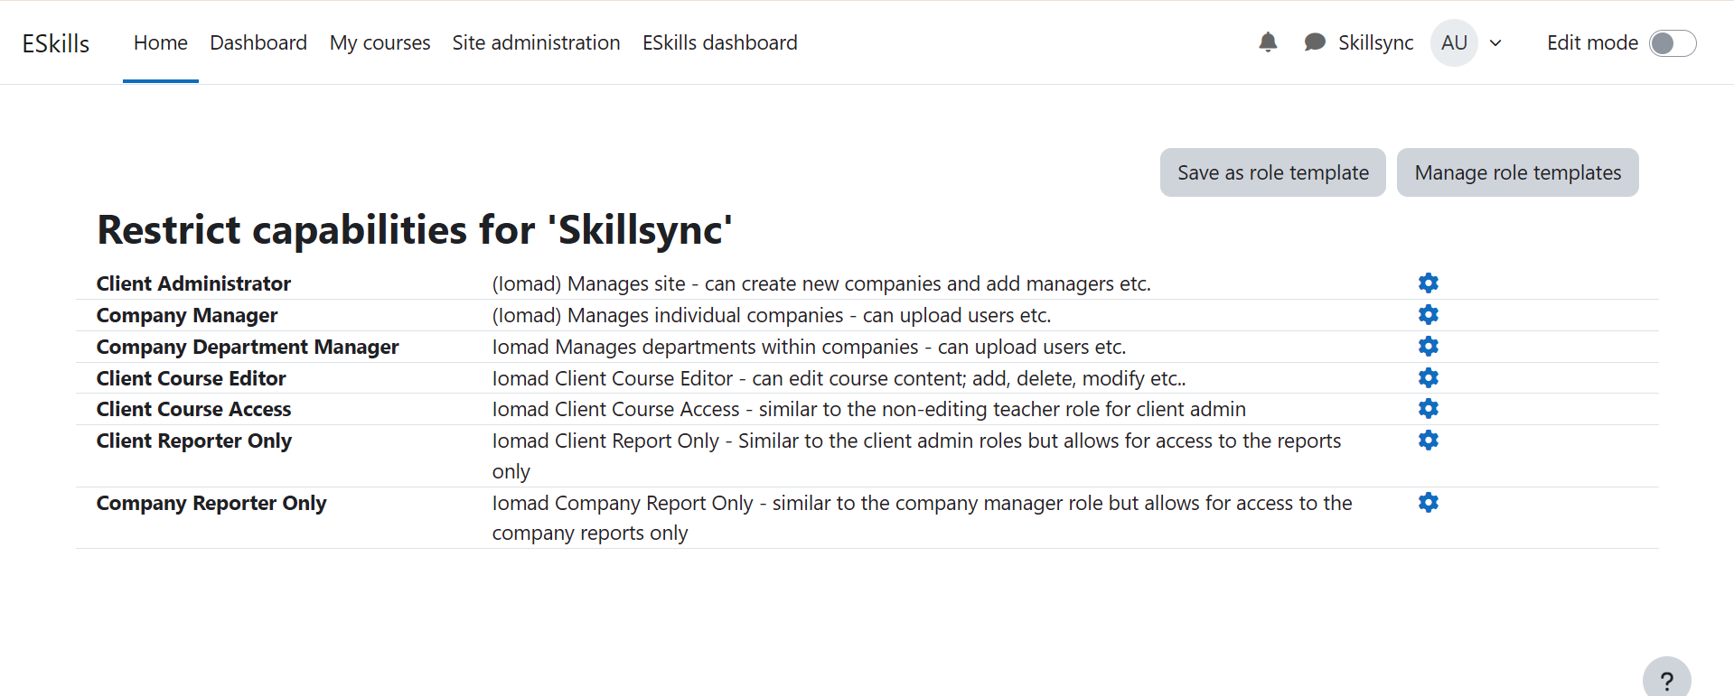
* **Custom Permissions:** Enable each company to configure custom permissions for users, based on the company’s specific needs.

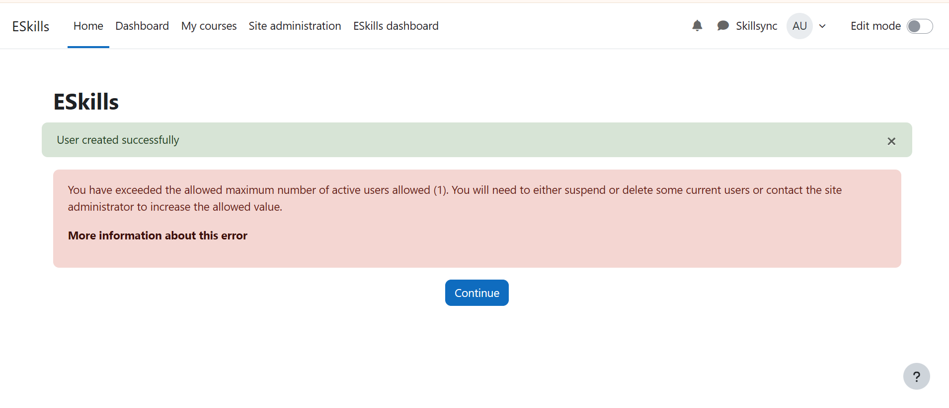  
2.3 E-Commerce Functionality and Payment Integration

**Description**

The system will allow companies to create and list their courses for purchase by other organizations. Secure payment integration will be provided through multiple gateways (e.g., credit cards, PayPal) to facilitate course purchases.  
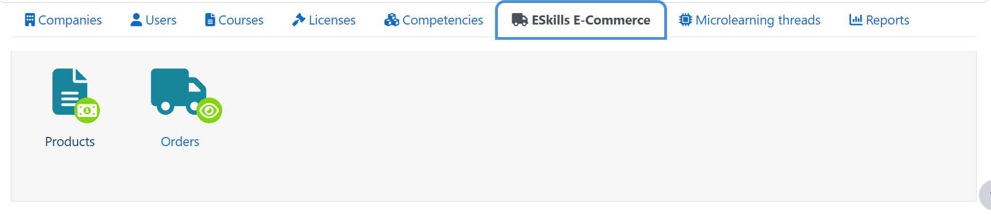

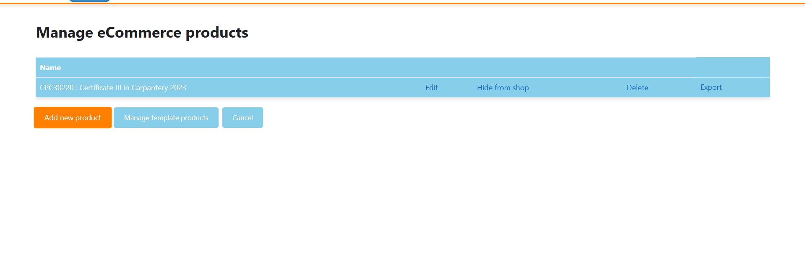

**Example**

Organization A creates a course on software development and lists it on the platform. Organization B browses the catalog, adds the course to their cart, proceeds to payment, and upon successful transaction, the course is added to Organization B’s course catalog for their learners to access.

**Feature Breakdown**

* **Course Catalog:** Display all available courses for browsing, complete with pricing, course details, and instructor information.
* 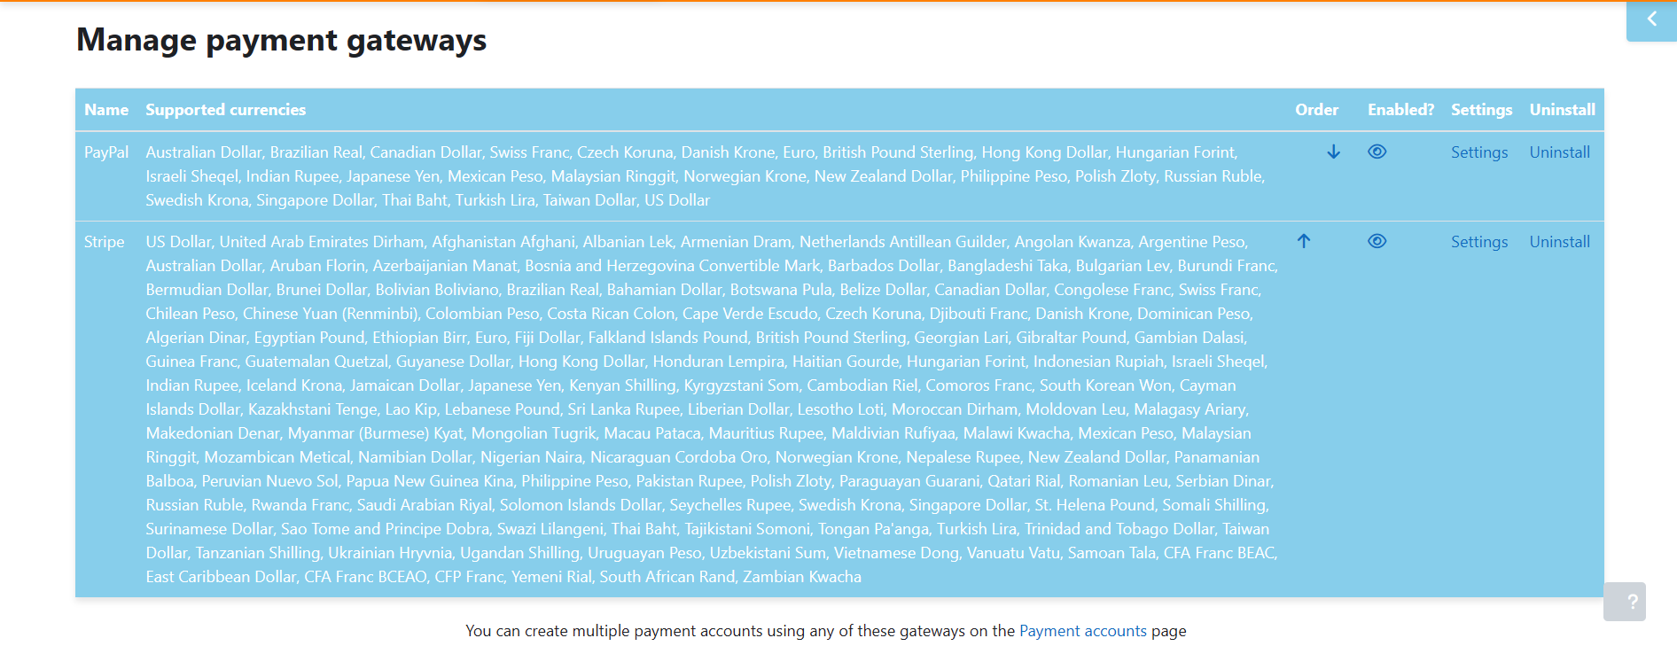**Payment Gateway Integration:** Secure payment processing, supporting multiple payment methods (credit card, PayPal, etc.)
* **Order Management:** Admins can track and manage orders, including payment status and course access details.

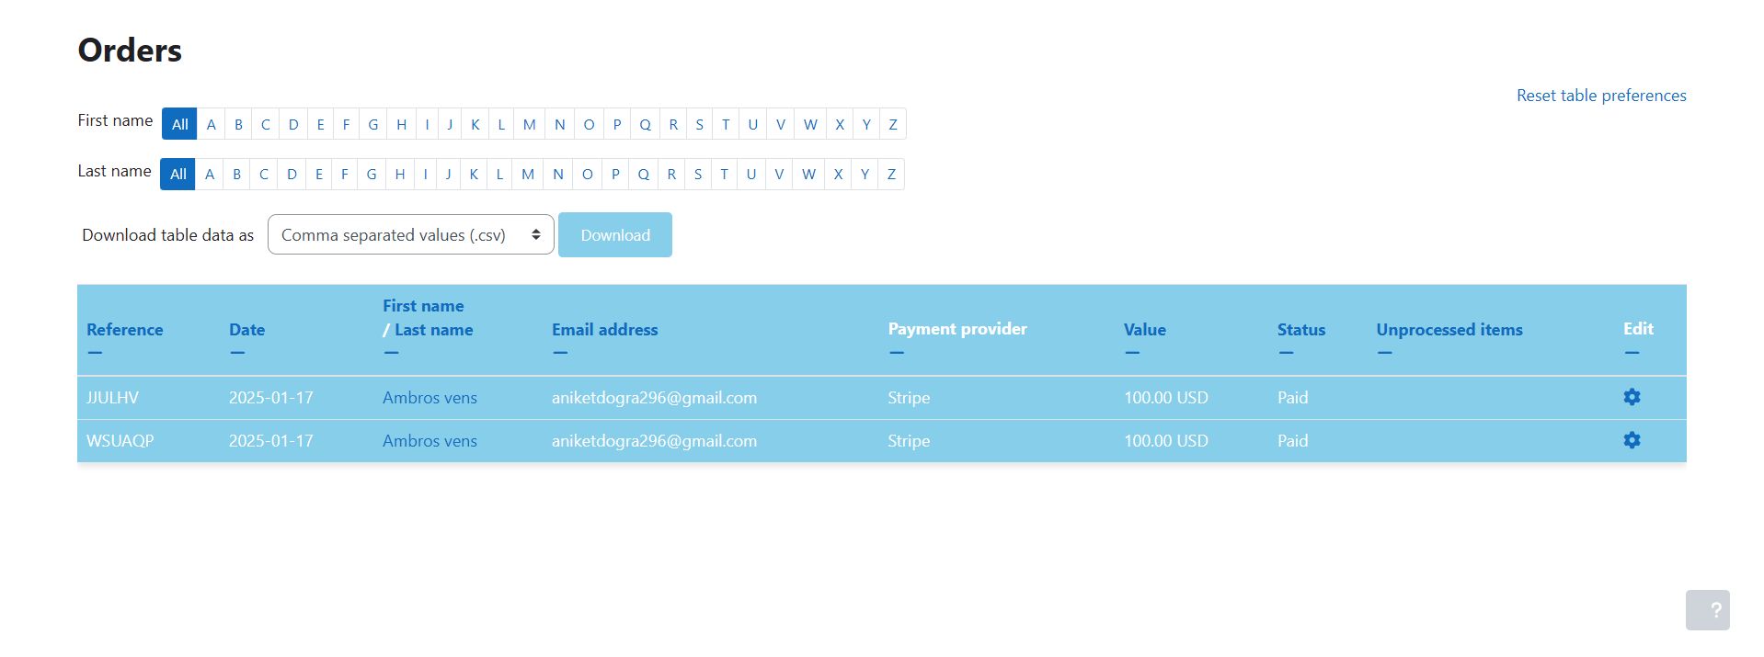2.4 Dashboards and Reporting

**Description**

The platform will offer dynamic dashboards for both company admins and learners. Admins will have access to comprehensive analytics on course performance, user engagement, and transaction data. Learners will see their personal progress and course completion details.

**Example**

The admin dashboard shows key metrics such as total revenue, user registrations, and course completion rates. The learner dashboard displays the courses they are enrolled in, their progress, and upcoming assignments.

**Feature Breakdown**

* **Admin Dashboard:** Overview of key metrics, such as revenue, user statistics, and course engagement.
* **Learner Dashboard:** Displays enrolled courses, progress tracking, and upcoming assignments.

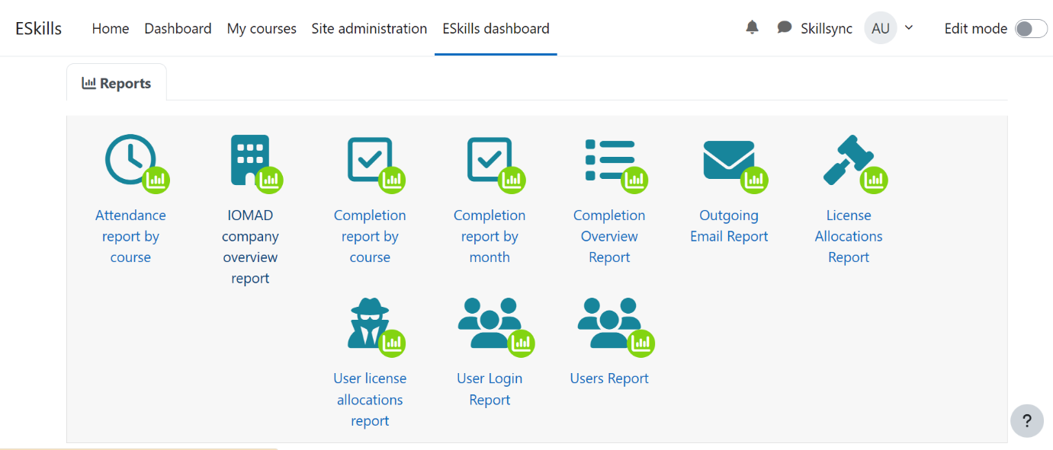3. Non-Functional Requirements

3.1 Performance and Scalability

**Description**

The system must handle a high number of concurrent users without degradation in performance. The platform should be scalable to accommodate more users, courses, and companies as the system grows.

**Example**

If a company adds a significant number of users or courses, the platform should scale seamlessly to handle the increase in data and user interactions.

**Feature Breakdown**

* **Load Balancing:** Distribute user traffic evenly to prevent slowdowns during peak usage times.
* **Data Scalability:** Ensure the platform can scale horizontally and vertically to manage more users, courses, and transactions.

**Placeholder for Snapshot**

Include a system load performance graph showing scalability and load balancing.

3.2 Security

**Description**

Security is crucial to protect sensitive user data, course content, and payment information. The platform will adhere to industry standards for secure transactions, data protection, and access management.

**Example**

Sensitive payment data will be encrypted and transmitted via secure protocols, ensuring users’ financial information is protected during transactions.

**Feature Breakdown**

* **SSL Encryption:** Secure all communication between users and the platform using SSL encryption.
* **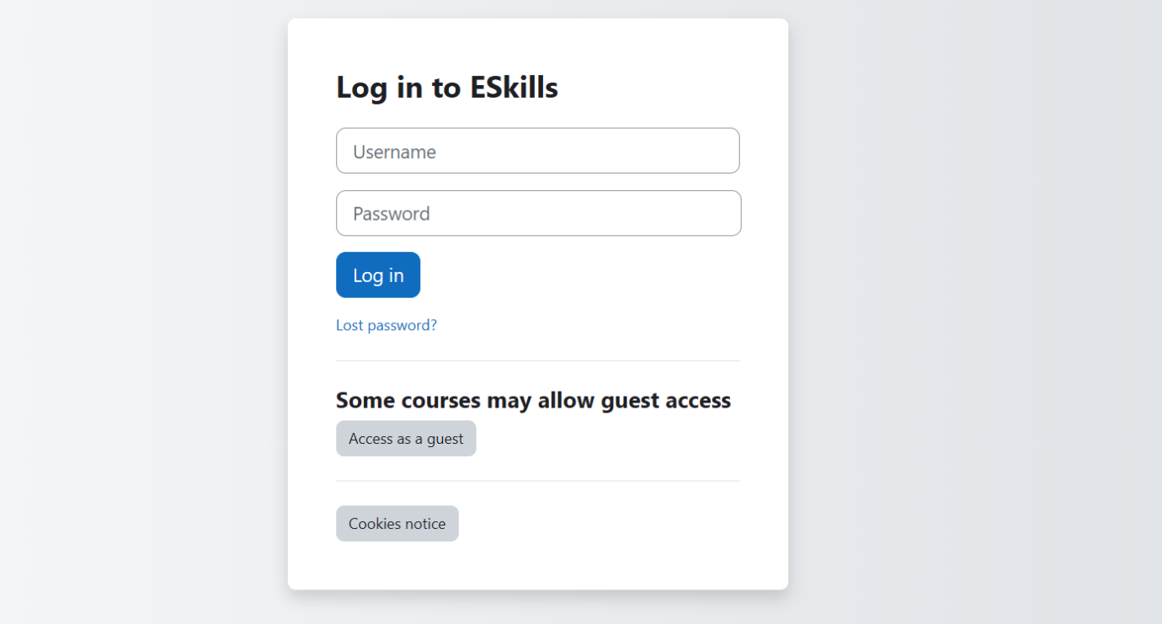****Data Encryption:** Protect sensitive user data, including payment information, both at rest and in transit.

3.3 Usability and Accessibility

**Description**

The platform should be user-friendly and accessible, following WCAG 2.0 standards to ensure it can be used by people with disabilities.

**Example**

The platform should support screen readers, keyboard navigation, and visual accessibility features, such as high-contrast modes, for users with visual impairments.

**Feature Breakdown**

* **Responsive Design:** The system must adapt to mobile, tablet, and desktop screens.
* 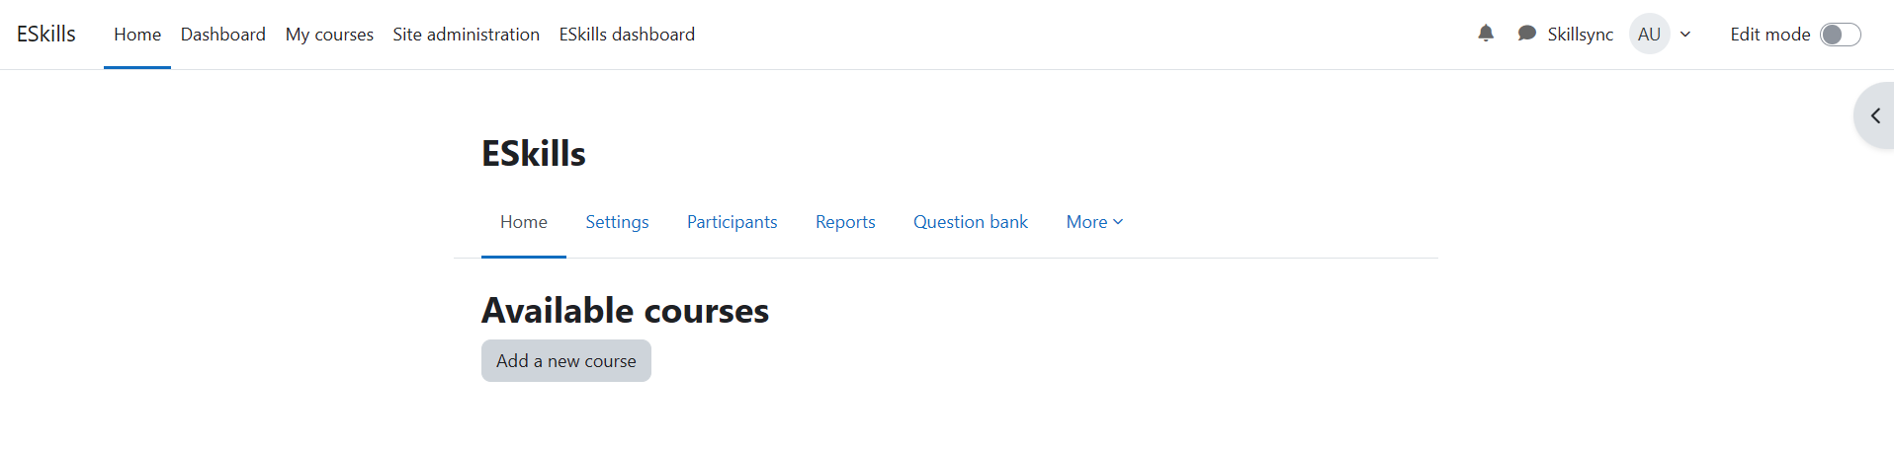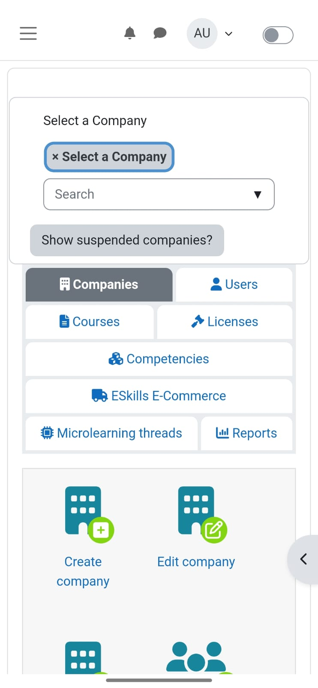**Accessibility Compliance:** The platform will meet WCAG 2.0 accessibility standards.

4. Advanced Features

4.1 Integration with External Systems

**Description**

The platform will integrate with external systems like CRM, ERP, or HR platforms to synchronize data and streamline operations.

**Example**

The platform will synchronize user data with an external CRM system, ensuring that user profiles and course progress are updated automatically across both systems.

**Feature Breakdown**

* **API Integration:** Enable seamless data exchange with external systems through RESTful APIs.
* **Data Synchronization:** Ensure real-time synchronization of user profiles, courses, and transactions.

5. Conclusion

This system will provide an integrated solution for multiple organizations to create, manage, and purchase courses securely. It will support scalable, customizable features, ensuring that each company has full control over its course offerings, user management, and payment processes. The platform will be user-friendly, secure, and designed to grow as the needs of clients and users evolve.